STOP MOTION Photography

You have two choices:
Create an artwork and document the process with stop motion photography
OR
Create a story and tell it with the process of stop motion photography

The Plan:
- Write a short paragraph outlining the story and completing storyboard templates outlining key shots of your stop motion.
- Identify your building/locating your “set” and props
- Identify your chosen a method of animating the characters (i.e clay models, action figures, lego, found objects and or found imagery, i.e. magazine imagery)
/10
Draw a basic storyboard and include:
- Rough sketches of images
- Music Plan
- Ensure you have a clear beginning and ending
/10

The Final Product:
/5 Posted on time
/5 Easy to find on your website & well laid out (creative and clean)
/3 Clear beginning and ending (including title & credits-without using your last name)
/10 Props or artwork is well made and professional
/5 Photography is free of distractions and professionally captured
/5 Photography is properly exposed and in focus
/5 Stop Motion is the correct speed (not too fast or too slow)
/5 Music is well-chosen and starts and stops at correct times
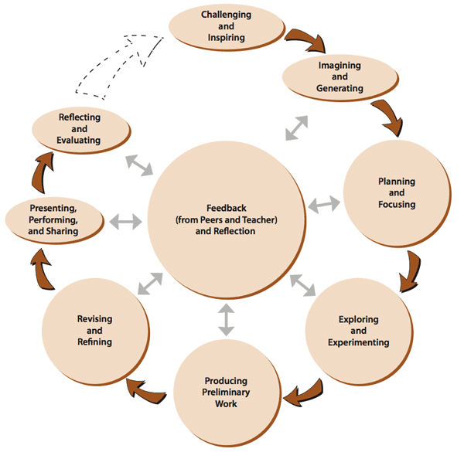
/2 Music sounds clear, loud enough, and professional

/35 TOTAL

/10 Reflection of the Creative Process
Paragraph Written on a separate sheet of paper or posted on your blog

Name: _____________________

