GIF Hybrid Project

Overview
A GIF (Graphic Interchange Format) is a file format that supports both static and animated image. GIF’s are often used in casual online messaging applications.
A gif is similar to a stop motion, but shorter and comprised of approximately five low quality images.

Choice One: Draw your GIF
For this option you will be taking a photograph and then create a simple coloured drawing (with a minimum of 5 colours). The drawing will be used to lay overtop the background image. With this option you will change the colour of either the drawn image of the photograph.

Choice Two: Photograph your GIF
For this option you will be taking a simple photograph and combining it with another colorful photograph (with at least 5 colours). The colorful photograph will be used to lay overtop the original image.

Order of Operations
- Plan your GIF, sketch it out.
- Take/Draw your photographs and drawings.
- If your drawing is the piece that will be changing colour you will need to colour it. If not, ensure your photograph consist of multiple colours.
- Open Adobe Photoshop.
- Import both images to Adobe Photoshop.

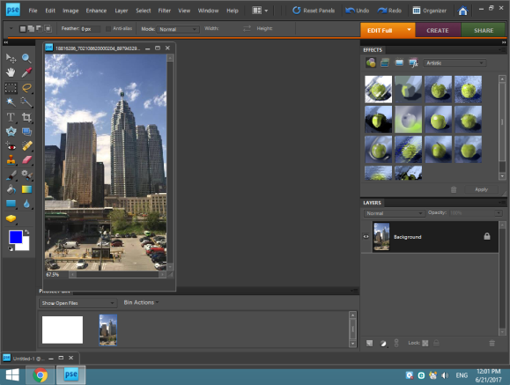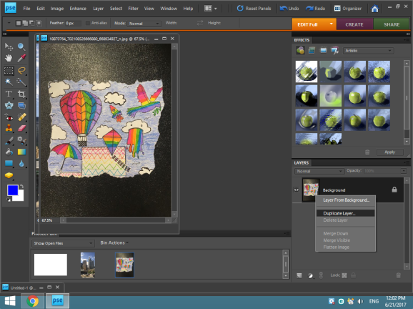

- Crop the images and overlap but do not merge yet. 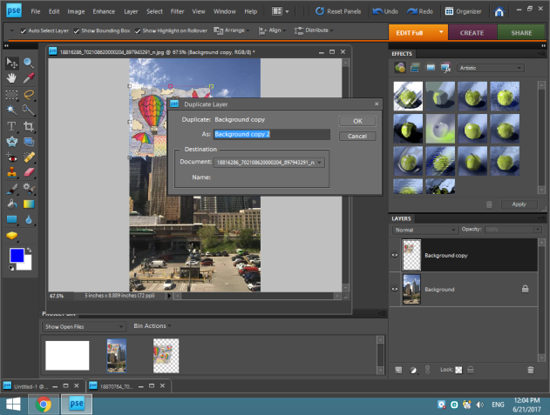

- Create the amount of layers in photoshop as frames desired with the color changing photo, your images should be a small size.
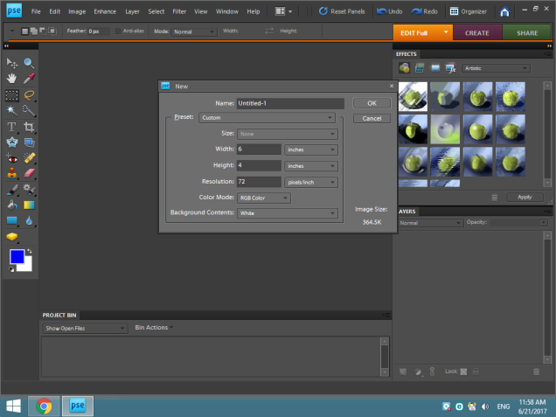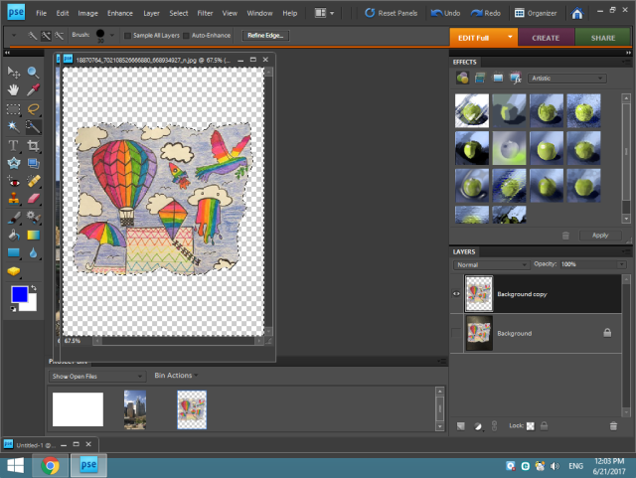

- Adjust the hue in the enhance section underneath the adjust hue and saturation subsection.
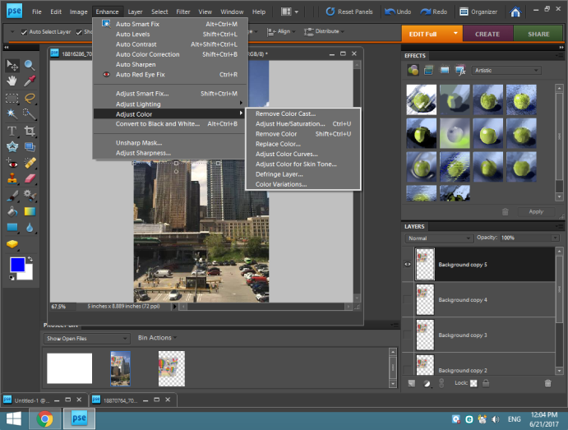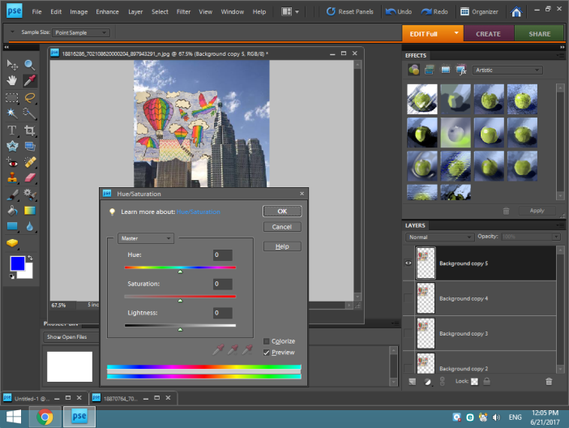
- Place your background photo layers between every colour changing photo.
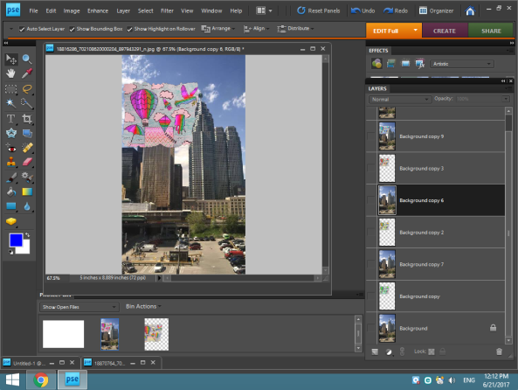

- Merge a background photo with a color changing photo, ensure the background photo is behind the foreground photo(underneath).
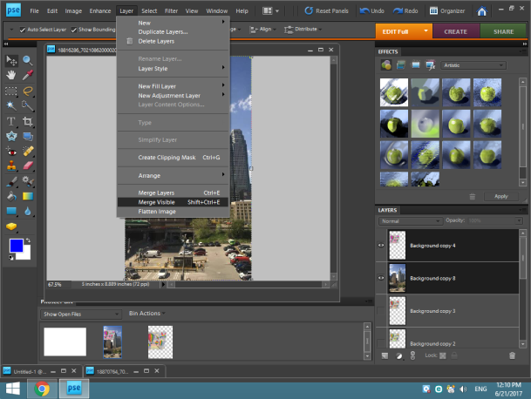

- Once all foreground photos have a background merged to them, save your layers to the web, select the GIF option check the animate box and deselect the transparent box.
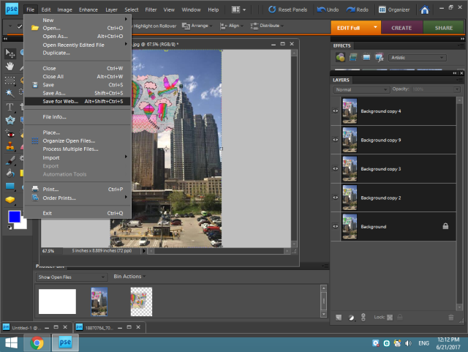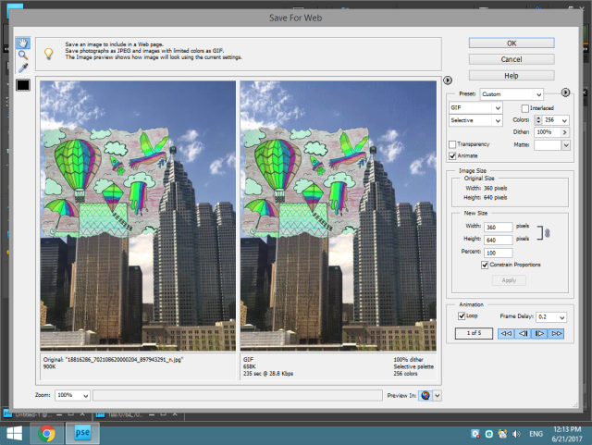

- Give the GIF a title.
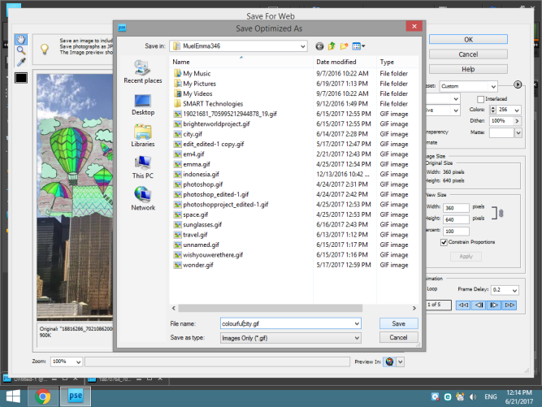
- Post to blog or other media.

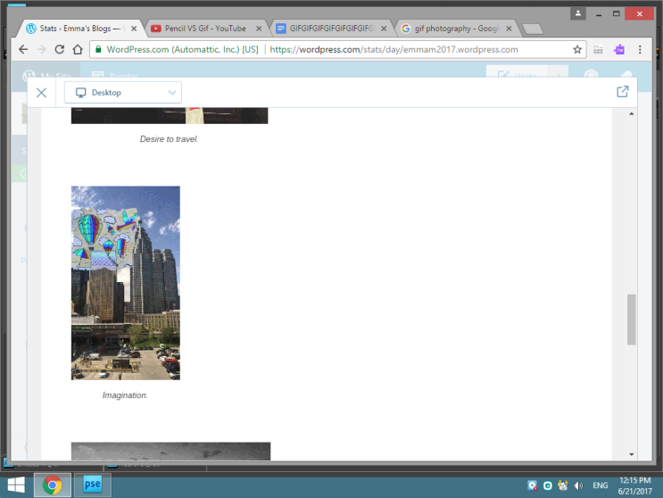

Created by: K. Fehr and E. Mueller 2017

