Colour Gif: Project ONE

Choose a photograph (must be your own) that has at least 5 different and prominent colours
OR
Draw a picture that has at least 5 different colours

NOTE: The more colours that are in your drawing or photograph, the better this project will work! Your photo size MUST be a small image. If you are taking a picture, your iphone will work great. If you are using the school cameras, change the setting to ‘small image quality’.

- Open you photo or drawing (can be scanned) in Photoshop.

- Right click on the layer and duplicate it approx. 10 times
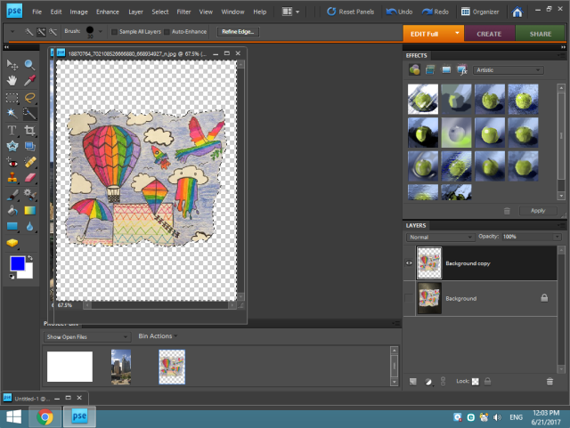
- Starting with one of the layer, adjust the hue in the enhance section underneath the adjust hue and saturation subsection.
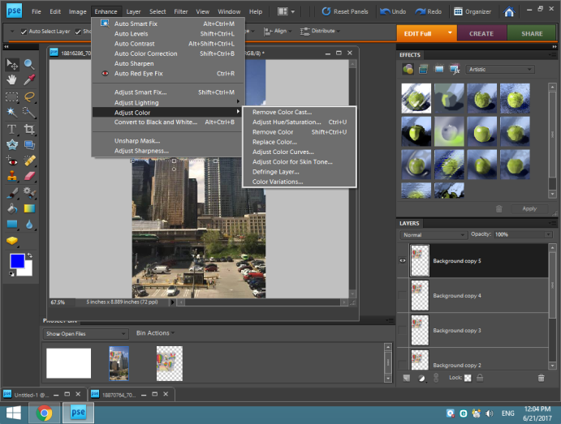
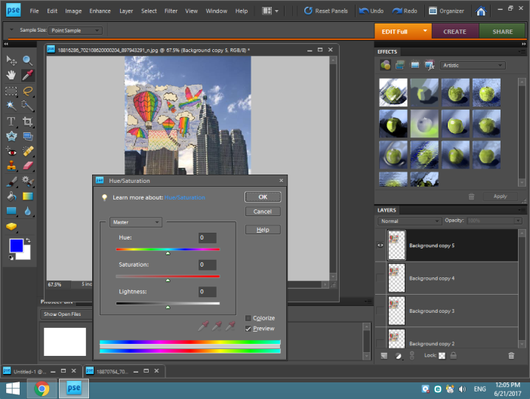

- On each layer, create (in a sequence) a colour change up/or down the colour grid.

- Once each layer is a different colour, save your file.
File-Save for Web

- Selelct the GIF option (check the animate box and deselect the transparent box).
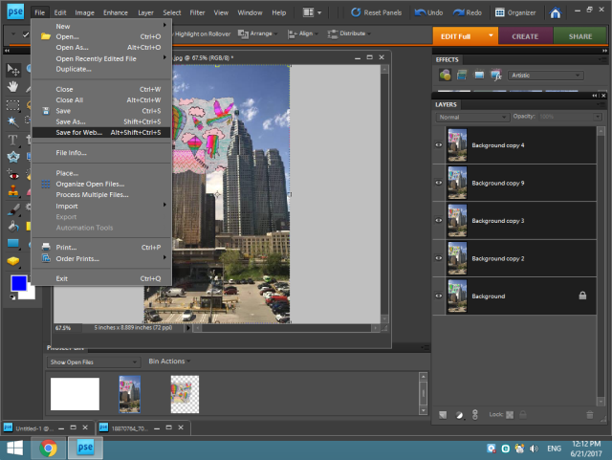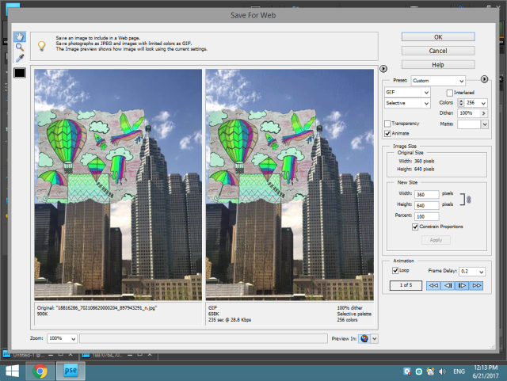

- Give the GIF a title.
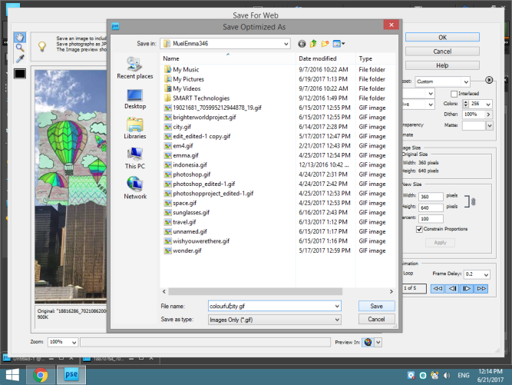

- Post to your blog. Title your page ‘Gif’

Animated Gif
* Gif posted to a designated page on your blog on time 1 2 3 4 5
*Gif successfully created in Photoshop 1 2
* Proper choice of seconds delay for faster or slower motion (great flow) 1 2 3 4
* Effective use of photography/drawing (great images for a starting point) 1 2 3 4
* Complex/Aesthetically pleasing 1 2 3 4 5
* Excellent evidence of thought, planning, and execution 1 2 3 4 5

Total: /
Name: _______________________ Date Posted: __________________________

