The Photoshop Starter Project
- Choose five of the following tasks. (complete 5/10)
- For two of the five projects, you need to use your OWN photographs. (2/5)
- All photographs need their sources cited, including your own photos!
- Post your images, sources, and task label on your Weebly site as one page clearly labelled ‘Photoshop’(5 tasks should sit on one page)
- All creations need to be classroom appropriate.
- Save your images as .psd (for editing) & .jpegs (for final posting)
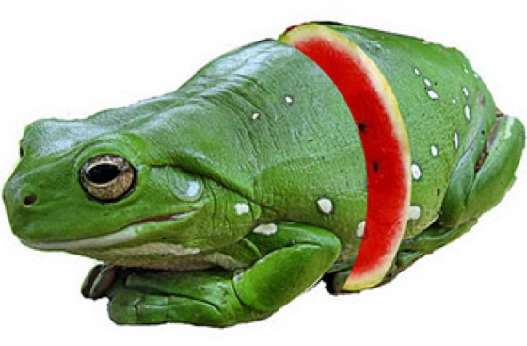
One: Something Sliced
What you choose and how you slice it is up to you, however, your best bet is to consider matching shapes, colors, textures and contours carefully.

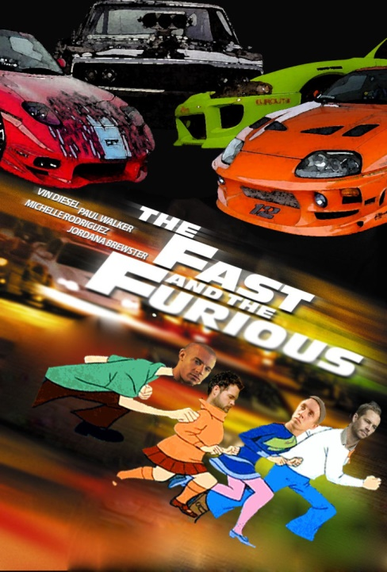
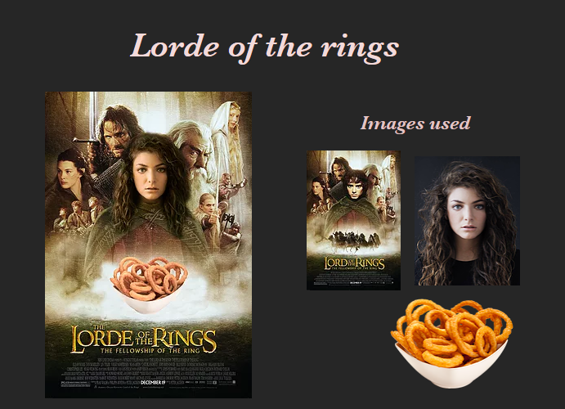
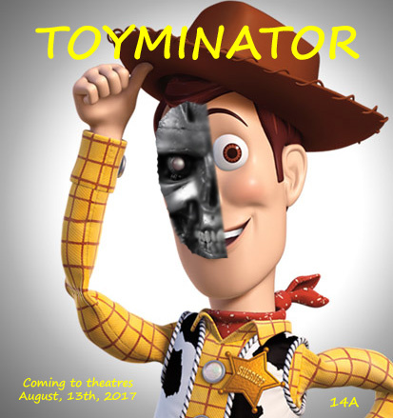
Two: A Funny Movie Poster Parody
Make a movie poster for a “different” kind of movie. How is it different? That’s up to you. Be creative. Be clever!

Maddy M, Toyminator, 2016 Fatima A., Lord of the Rings, 2019

Matt C, The Fast & Furious, 2016
Three: Some Scrambled Bodies Looking All Crazy!
This body part might not go here and that part might not go there. Mix up some body parts.
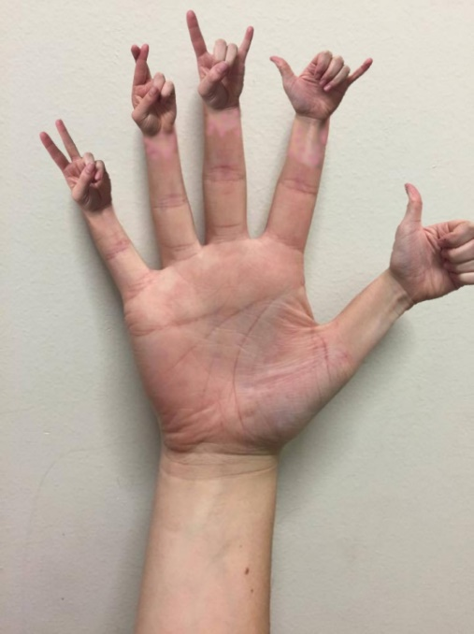
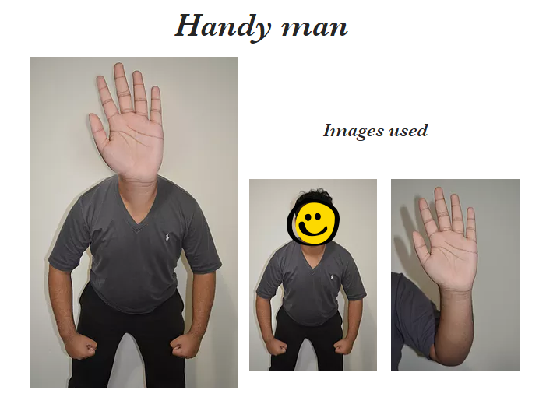
Fatima A., Handyman, 2019

Maddy M, Spelling Hands, 2016

Four: Show Something in Motion
By using the right object and just enough blur you can make sure your object in motion will tend to stay in motion.
Five: Really Scary Signs!
Show us the signs we do not want to see.
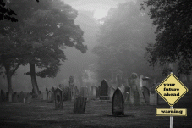 Emma M, 2016

Six: Normal Extremes!
Take something everyday, common, normal and make it extreme! What about kitty chow for velociraptors? What if the five day forecast was Monday: asteroids. Tuesday: nuclear destruction?
Seven: Literal Interpretations!
Pick five compound words and create 5 images that depict literal interpretations.What would a fly look like if it were on fire? Firefly. What would the moon look like if it were made of honey? Honeymoon.
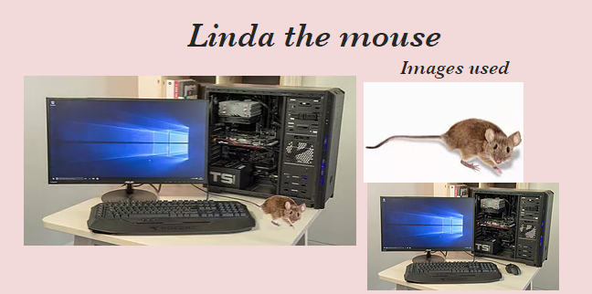
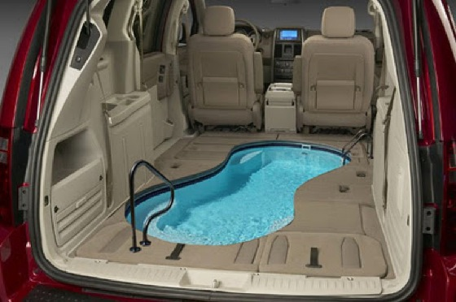 Carpool Computer Mouse, Fatima, 2019
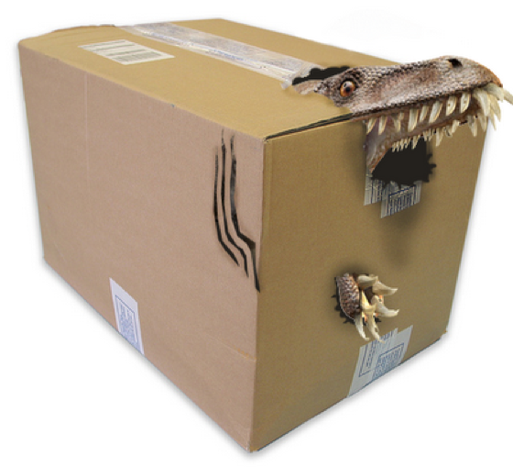
Eight: What’s in the Bad Mail?
There’s a bumpy package on the doorstep with a lion’s tail hanging out the back. There’s something very wrong with that envelope. We just got a letter, the worst letter you can possibly imagine. Show us the bad mail!

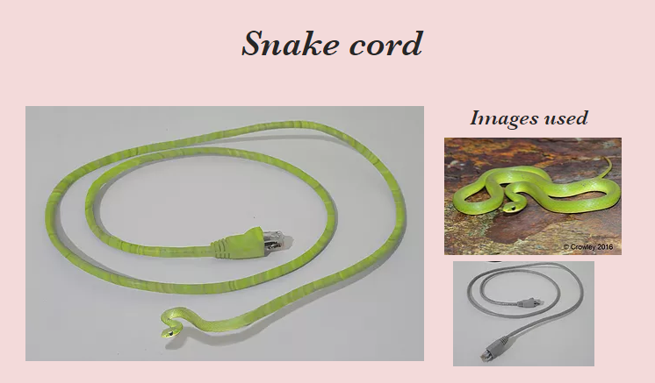
Nine: An Inanimate Object Brought to Life!
Used your photo manipulation skills to bring an inanimate object to life like a tree or a fork.

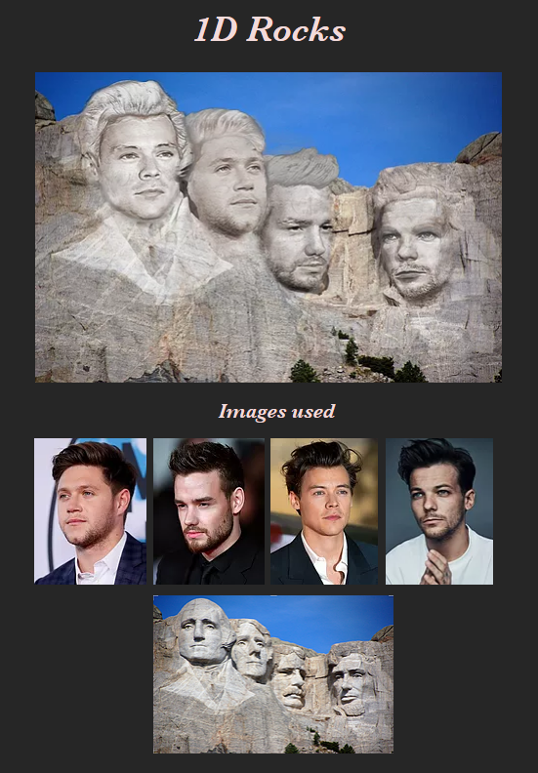
Ten: Turn a Pop Icon into a Sculpture!
Pop icons range from toys like Barbie to singers like Ke$ha. McDonald’s French fries might even be considered a pop icon. Sculptures range from ancient ruins like Easter Island to modern day artists like Calder or Segal. Both the pop icon and the sculpture should be easily recognized by your audience.
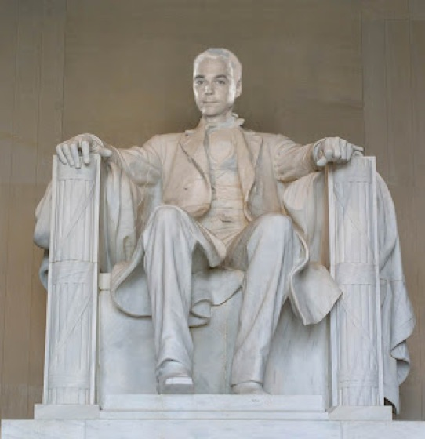
Fatima, 1D Rocks, 2019
Marking Section: FIVE of the ten will be graded
HIGHLIGHT OR CIRCLE THE 5/10 THAT YOU HAVE CHOSEN TO COMPLETE.

Something Sliced
Have you matched shapes, colours textures and contours?
Is the image professional and seamless?
1 2 3 4 5

Funny Movie Poster Parody
Is there a clear difference in the parody that you have created?
Is the new poster seamless and convincing? Making the viewer do a ‘double take’?
1 2 3 4 5

Scrambled Bodies
Is the use of body parts classroom appropriate and used in a creative and fun way?
Appropriate number of body parts are mixed up (4-5 depending upon the Photoshop details).
Are the body parts attached in a professional and seamless way?
1 2 3 4 5

Something in Motion
Is the object in motion well thought-out?
Have you created appropriate ‘blur’ to show motion?
Is the object and background professional, seamless and convincing?
1 2 3 4 5

Scary Signs
Is the sign you have created a sign that you NEVER want to see?!
Is the image professional and seamless? (Visually unable to know what originally existed and what changed)
1 2 3 4 5

Normal Extremes
Have you chosen an appropriate ‘normal’?
Have you chosen an appropriate ‘extreme’?
Is the image professional and seamless? (unable to know what originally existed and what changed)
1 2 3 4 5

Literal Interpretation: Compound words gone literal (ie honeymoon or firefly)
*Put the word you created on your website, as a label.
Is your word clear in your image?
Is the image professional and seamless? (unable to know what originally existed and what changed)
1 2 3 4 5
Bad Mail
Is your image clearly a mailed package?
Have you effectively imagined the worst mail ever!
Is the image professional and seamless? (unable to know what originally existed and what changed)
1 2 3 4 5

Inanimate Object Brought to Life
Is you starting object a wise starting choice (an object that does NOT naturally move)?
Have you effectively given it life in a creative way?
Is the image professional and seamless?
1 2 3 4 5

Pop Icon into a Sculpture
Is your pop icon clear and recognizable?
Is your sculpture easily recognizable?
Is the final image professional and seamless? Convincing the viewer this is the sculpture!
1 2 3 4 5
--------------------------------------------------------------------------------------------------------------------------------------------------
Personal Images/Citing Sources
Where appropriate did you use your own images? (at least 2 of the 5)
Excellent, clear, correct sized images (starting point is 8x 10 inches or 5x7 inches & 150-200 pixels/in)
Did you include links/works cited for all the images that you borrowed, as your starting point?
Is the citing clear and easily linked to each image used?
1 2 3 4 5 6 7 8 9 10

Website Details
Are you images properly placed on your website by the deadline?
Have you labelled your images with captions, based upon the task?
Have you arranged your webpage in a creative, yet informative way?
1 2 3 4 5 6 7 8 9 10
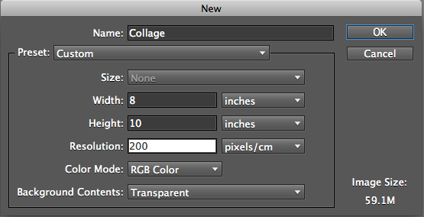

Name: __________________________

Grade _________/45

