Flash: The Genesis of Animation

Before you start with the Flash program you need to create a character that can be animated. This character is only limited to your imagination, but it must have limbs/parts that move. You must complete this animation project using the Flash program, in class.

Draw/Create a character in totality (all its body parts).
You have two different choices to create your character.

Using a Tablet/Photoshop | Traditional Medium (pencil/pen)
Separate all the moving parts away from the main body source.  Place all the body parts onto separate layers.  Ensure that your background is transparent.  Save each of the layers as a single .png image.  When you are done, you will have multiple images named after each body part. | Draw the complete creature/character on one sheet of paper.  Using the light table, trace each limb and moving piece as a separate image.  Trace out your good copy in black sharpie. Colour in your character.  Photograph each of your works.  Import them to Photoshop, each as separate files.  Using the magnetic lasso tool, remove the background and leave the body parts on a transparent background.  Save each body part as a separate .png
Create a background for your character. This can be a drawn background or it can be a photograph that you have taken. This file could be a .jpeg or a .png.

You will be marked on the professionalism of your drawn character AND your ability to animate your creation in flash.
Ensure that you give yourself 2-3 class days to create a creative and well-designed creature. In these days, you also need to be ‘preplan’ how you want your creature to move. Complete a story board of the movement of your character.
Your animation should take 1-2 class days. This is a week-long project.
Open Adobe Flash

Requirements:
You must have the following movements in your animation:
- Use of a Motion Pre-set (can be used to put your full character into the background)
- Classic motion tween (you set the motion intervals manually for body parts)
- Motion tween (you set the beginning motion and the end motion and it is automatically animated)
  - On the plane (ie right-left)
  - This motion must be used a total of 3 times.
- Motion tween (to make your character disappear into the distance, full body)
  - Foreground to Background
- By the time you are done, you will have a total of six different motions.
Getting Started:
- New File
Create your file size based upon your desired output:
Computer/Presentation 8x10in
Smartphone 5x7in
ActionScript #3 (Allows for Shape Tweens, ActionScript #2 only allows Classic and
Motion)
- File-Import-Import to Library (import all your .png images which when placed in the timeline must be converted into a symbol, under the Modify Tab. If you use Photoshop you can import all the layers of your image at one time)

Your screen consists of the white area called the “Stage” and the “Timeline.” (Ensure a window labelled “Timeline” and the “Ruler” are visible.) In this area…

Classic Tween
- The first layer is already present usually designated as the background. The background colour can be changed by either a) under the Modify tab and Document sub tab or inputting an image or photograph where you want your character to ‘exist’. Click on the first frame (1 in the timeline) click Insert/ /Timeline/ Keyframe and then go to Library and drag your photo to sit beside the stage. Place it beside the stage. At the 30 sec mark insert another keyframe, then click anywhere within the 30 sec and Click insert Classic Tween. At 5 sec interval’s you can either click insert keyframe or just click frame to highlight it and move the picture. At each 5 sec interval move, resize, rotate or flip your image. The last frame should have your image sized and placed fully on the Stage.
- New Layer-This is the complete body of your creature. Click on the first frame and then go to Library and drag your ‘body’ onto the Stage. Then position your character where you want them to start from (this is where your character will stand and move its limbs). Click on the amount of time you want your body to exist (it may be the same time as your background) right click and ‘insert key frame’. This is the length of time that your ‘body’ will exist in that location. Lock the body layer.
- Insert Folder, label it “Background” and place both the background file(s) and figure layers into it.

Motion Tween

- Insert another Folder and label it “Figure,” create a layer for each of the body parts and move all body part layers under this folder.

- New Layer-add a limb. Click on the 10 sec mark, right click “insert key frame.” You now have ‘selected’ a section between 5 & 10 secs. Now, select your limb on the stage and rotate it. Then reposition it back into the socket. Repeat the above process at 5 sec intervals to make a waving or ‘dancing’ motion. Move your cursor to the sec 1 and using the shift key select your intervals until the end of the movement. You have created a Stop Motion Animation
- New layer – add a limb: Title layer: “L-limb Classic.” Layer timeline extends from ‘0’ to the already defined end of the time line. At the beginning time the body is, insert keyframe, then insert/Classic Tween. Open library and drag limb onto stage, reposition it to match where it belongs on the body. Use the ruler and guide lines for positioning purposes. Click on the last frame, right click “insert keyframe” and rotate the limb to the final position of your movement. Use the slider to move from 1st position to last. Modifications to the movement can be achieved through adding keyframes and changing the limb position.
- New layer – add a limb: Title layer: “R-limb Motion.” Insert keyframe -add a limb and position it to match where it belongs on the body. Insert/Motion Tween. You will be asked to change image to “symbol” click “ok.” Click on the last frame, right click “insert keyframe” and rotate the limb to the final position of your movement. Use the slider to move from 1st position to last. Modifications to the movement can be achieved through clicking the limb, changing position then moving to the next location and moving that image. No more needing having to insert keyframes. A pathway will be visible on the stage to show the movement of the limb.
- New layer – add a Head: Title layer: “Head rotation.”
- “Head Shape Morphing Motion.” Insert keyframe -add a head and position it to match where it belongs on the body. Click Modify/Break Apart. At various places in the timeline you can add shapes, text or other images to morph into, making sure that any of these elements have “Break Apart.”

- At the 20sec time element insert keyframe add limb at the end position. Click space between first and last positions, right click or “Insert/Motion Tween. At 5 sec intervals click, insert keyframe and change position of the arm. You should notice that a row of dots appears on the stage to denote the movement of the limb. Insert Keyframe at the end frame.
- Right click and “Create Classic Tween”. This will smooth out the motion into an animation.
- Another Option: Click on the initial time of movement (insert key frame), click on time’s end point of movement (insert key frame), click on the first, time frame (insert image from library). Position the limb. Right click insert “motion tween”. Click the last frame and position the limb where you want it to end. With the “motion tween” that you have set, the motion will be created smoothly and automatically.

Shape Tween
- New Layer-This is the complete body of your creature, again. Click on the first frame and then go to Library and drag your ‘creature’ onto the Stage. Then position your character where you want them to start from, right click and ‘insert keyframe’. Click ‘Modify/Break Apart’. Click for a 20 sec sequence then click, ‘insert keyframe’ and using the draw tool draw a shaped form, adding a different colour. Position your shape on the opposite side of the stage to you figure. Test to see the result.
- Option can add multiple shapes to morph into by adding 10 sec sequences of time. To change the direction of the movement of the object, click ‘insert keyframe’.
- The last sequence is to end with your creature.

Embedded Tweens
TIPS:
- Check your progress by pressing ‘play’ to see the animation that you have started.
- You can animate limb motions to be happening at the same time or you can stagger them on the timeline, so different limbs move at different time.
- Once you have your
- Give your layers names, by double clicking. This will help you stay organized.
- Under view tab, click on rulers and then you can apply exact locations by adding guide lines.
- Your 1st background layer should always be at the bottom of your layer list.
- Once you have properly positioned your background and main body, lock them in place by clicking the layer and lock section.
- Every time you need to change a position you need highlight a keyframe.
- You can drag and drop keyframes to increase or decrease timeline length
- When you are finished with a layer, it should be locked.
- You will notice the difference between using the Classic and Motion Tween
- If you make a mistake right click “Remove Frames”
When you have finished your animation, export into a movie. File-Export. Upload this movie to your YouTube and post it on your website under the heading ‘Flash’ or ‘Animation’.

Marking Scheme:

Planning: I have a clear story-board plan /10
Process: I was in class everyday creating, helping others and asking questions! /10
Creature Creation: My creature is creative & completely my design
(it is okay to use sources of inspiration as starting points) /10
Professionalism of Creation: My creature was well drawn, detailed and professional. /10

Animation: I have six of the required correct motions in my animation /12
Animation: The background image is an appropriate choice for my animation /10
Animation: My motions creative and well-planned, appropriate for my creature /5
Animation: Exploration of a movement that was not required (creativity) /5

Website: I have saved and posted my animation…
on a new page; well laid-out/designed; posted on-time. /5

Website: Reflection is posted on my website /3
Reflection: Well-written, no errors, clear and detailed reflection of the creative process. /20

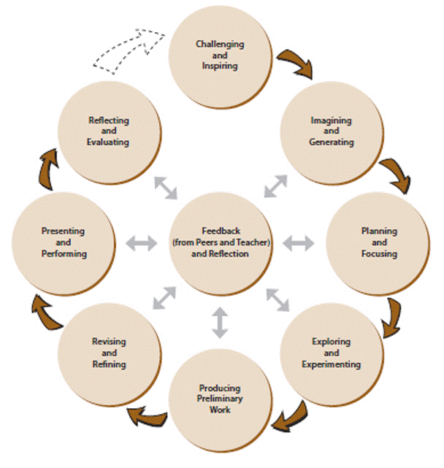
Total /100

